**Android GestureDetector Example**

In android can listen to the gestures and events performed by user on screen.  
  
To listen the Gestures in Android we need to do 3 things  
**1:** Create Class GestureListener which should extends GestureDetector.SimpleOnGestureListener  
**2:** Override s all the callback methods of GestureDetector.SimpleOnGestureListener  
**3:**  Bind the gestureDetector to GestureListener

**GestureListener.java**

class GestureListener extends GestureDetector.SimpleOnGestureListener  
{  
      
       static String currentGestureDetected;  
         
 **// Override s all the callback methods of GestureDetector.SimpleOnGestureListener**  
      @Override  
      public boolean onSingleTapUp(MotionEvent ev) {  
          currentGestureDetected=ev.toString();  
         
        return true;  
      }  
      @Override  
      public void onShowPress(MotionEvent ev) {  
          currentGestureDetected=ev.toString();  
          
      }  
      @Override  
      public void onLongPress(MotionEvent ev) {  
          currentGestureDetected=ev.toString();  
         
      }  
      @Override  
      public boolean onScroll(MotionEvent e1, MotionEvent e2, float distanceX, float distanceY) {  
          currentGestureDetected=e1.toString()+ "  "+e2.toString();  
        
        return true;  
      }  
      @Override  
      public boolean onDown(MotionEvent ev) {  
          currentGestureDetected=ev.toString();  
          
        return true;  
      }  
      @Override  
      public boolean onFling(MotionEvent e1, MotionEvent e2, float velocityX, float velocityY) {  
          currentGestureDetected=e1.toString()+ "  "+e2.toString();  
        return true;  
      }  
}  
  
  
**MainActivity.java**  
  
public class MainActivity extends Activity   
{  
             
            private GestureDetector mGestureDetector;  
            @Override  
            protected void onCreate(Bundle savedInstanceState)   
            {  
                    super.onCreate(savedInstanceState);  
                    setContentView(R.layout.activity_main);  
                      
                   **// Bind the gestureDetector to GestureListener**  
                    mGestureDetector = new GestureDetector(this, new GestureListener());  
            }  
  
            // onTouch() method gets called each time you perform any touch event with screen   
            @Override  
            public boolean onTouchEvent(MotionEvent event)  
            {  
     //method onTouchEvent of GestureDetector class Analyzes the given motion event   
     //and if applicable triggers the appropriate callbacks on the GestureDetector.OnGestureListener supplied.  
     //Returns true if the GestureDetector.OnGestureListener consumed the event, else false.  
                  
                boolean eventConsumed=mGestureDetector.onTouchEvent(event);  
                    if (eventConsumed)  
                    {  
                       Toast.makeText(this,GestureListener.currentGestureDetected,Toast.LENGTH_LONG).show();  
                        return true;  
                    }  
                    else  
                        return false;  
            }  
}

[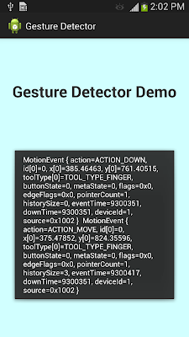](http://2.bp.blogspot.com/-bHDmWk-LrwM/UcrcAHgmKMI/AAAAAAAAAgA/IaxPepPum0U/s1600/gesture.png)